Outcome 1: Project Design

|  |  |
| --- | --- |
| **Class: CISCO IoT** | **Year: 2021** |
| **Candidate Name: Kamila Maciejczak** | **Candidate ID: EC2043537** |

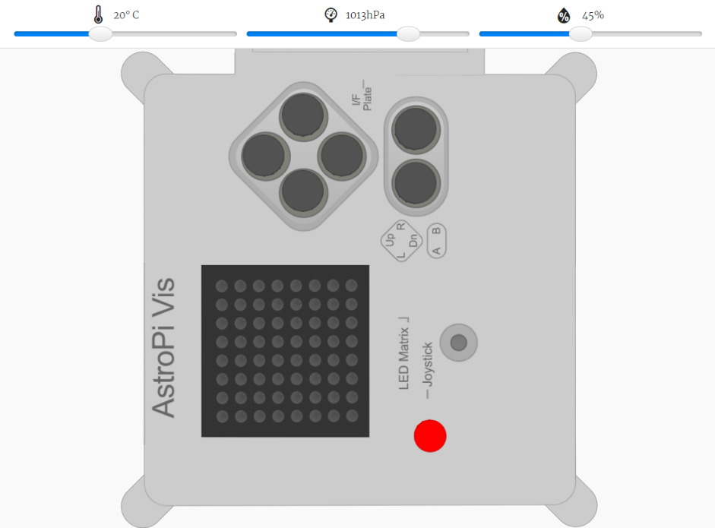My project will be a weather sensor, that will be programmed using Sense Hat and displayed on the Astro Pi emulator on trinket.io/sense-hat. By the built in sensors on Astro Pi, program will track the variables of temperature, pressure and humidity, report it to the user by displaying a message whether the readings are high, normal or low.

Program will start with the menu options of tracking heat, pressure and humidity and also will give user option to exit program. User will be able to select one from range of options by using joystick directions within a Sense Hat. Arrows left/right/up will allow user to select option whether it will be temperature, pressure or humidity readings taken by the sensors, or to exit the program, then to accept user will have to press down arrow. After variable will be selected, then user will be able to choose how many readings will be taken by the sensor from 0 to 100 and while chosen 0, then program will return to the start menu again.

If choice will be above 0, program then will track the readings from the sensor in the 1 second intervals and display it. After whole process is finished, program will display a message whether the readings are high, normal or low and two option for a user: save or discard readings (date, time, data). After the user choice program will return again to the start menu.

To create this project I need Windows 10 and IDLE (Python 3.9 64-bit), also I will use my Laptop Asus X555L (any really modern computers aren’t needed in this sort of project). Project will be tested on the online emulator on trinket.io/sense-hat on the Chrome browser.

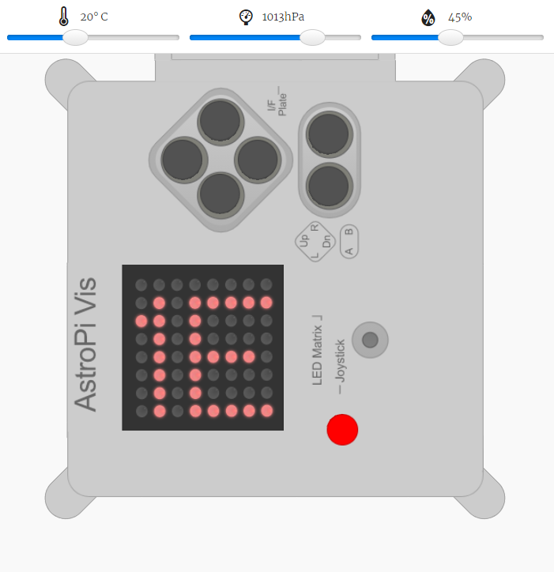

Firstly AstroPi Vis displays MENU option for the user.

User must choose from three options by using joystick (arrows on keyboard)

Left – Temperature (T)

Down – Pressure (P)

Right – Humidity (H)

To save the choice user have to press Up.

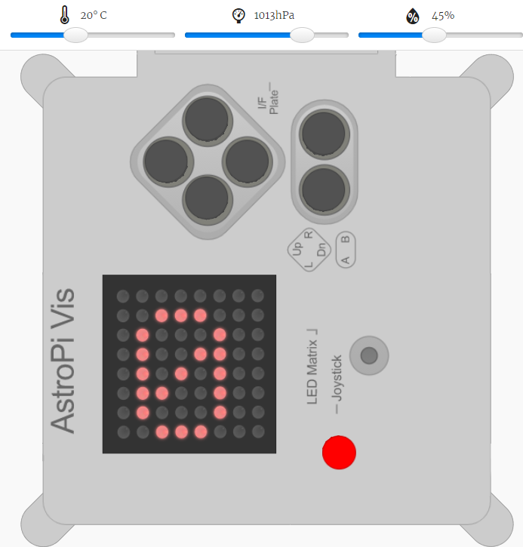

Once type of data has been chosen, AstroPi Vis emulator will display word Measures and will allow user to choose a number of measures to be taken from 1-100 (while leaving it on 0 will return back to the MENU options).

To save number of measures to be taken user have to press Up, to deny press Down and the program will move user back to the MENU options.

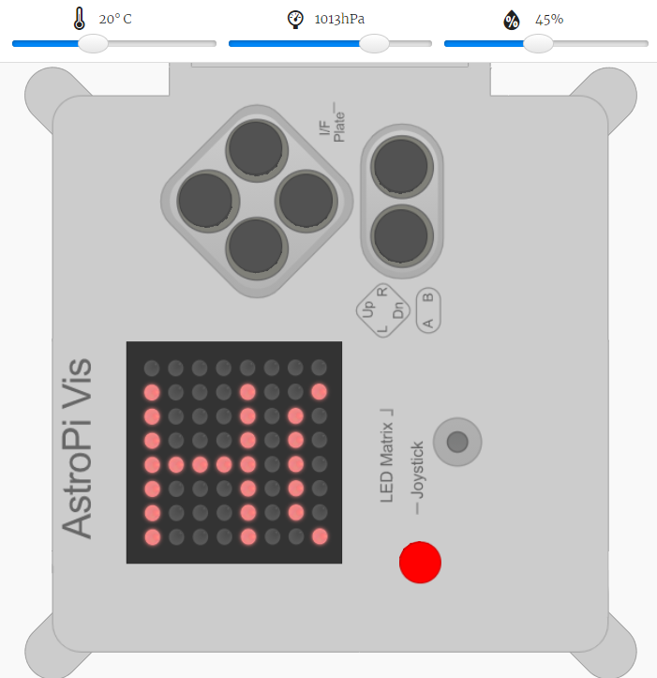

In case of Temperature readings (T) after each measure program will display a message to the user whether the temperature is HOT, NORMAL or COLD.

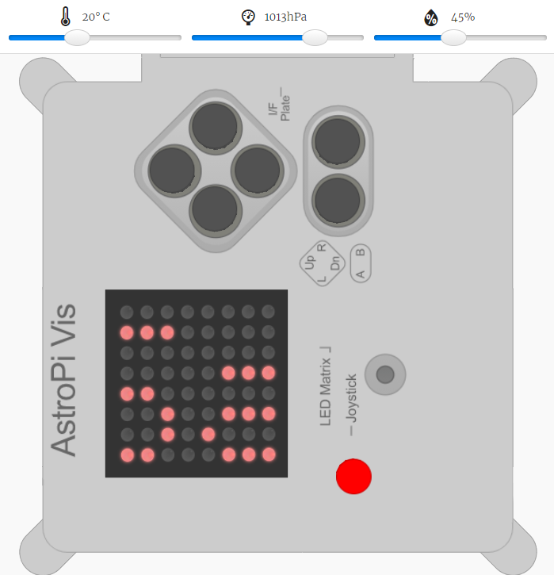

After each measure and each message will be displayed, program will give user an option to save all measures taken in the external document on the computer in the format of date, time and data. Once user choice is to save it, then program will show message “Saving…” and “Saved” (otherwise – error).

Program returns back to the MENU options.